**Project Initialization and Planning Phase**

| Date | July 2024 |
| --- | --- |
| Team ID | 739675 |
| Project Name | Drug classification using machine learning |
| Maximum Marks | 3 Marks |

**Define Problem Statements (Customer Problem Statement Template):**

The pharmaceutical industry struggles with accurate drug classification due to manual, error-prone methods. We propose a machine learning model to classify drugs based on chemical properties, mechanisms of action, and therapeutic uses. This model, using Python and libraries like scikit-learn and TensorFlow, aims to improve accuracy and efficiency. Enhanced classification will support drug discovery, regulatory compliance, and personalized medicine. Ultimately, this solution will optimize drug development and enhance patient safety.

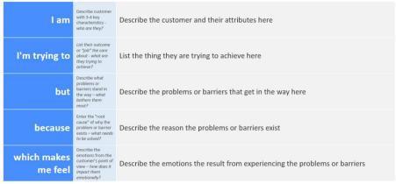

**Reference**: https://miro.com/app/board/uXjVK2aqlmY=/?share_link_id=534024970903

**Example:**

| **Problem**  **Statement (PS)** | **I am**  **(Customer)** | **I’m trying to** | **But** | **Because** | **Which makes me feel** |
| --- | --- | --- | --- | --- | --- |
| PS-1 | A pharmaceutical researcher or healthcare professional. | Accurately classify different types of drugs based on their chemical properties and potential effects. | The process is time-consuming and prone to human error due to the complexity and volume of data involved. | Manual classification requires extensive knowledge and experience, and even minor inaccuracies can lead to significant consequences in drug development and patient care. | Frustrated and concerned about the efficiency and reliability of the drug classification process. |
| PS-2 | A healthcare data analyst. | Identify and classify new drug compounds rapidly and accurately from vast datasets. | The traditional methods are not scalable and often fail to capture the intricate patterns in the data. | These methods rely heavily on manual analysis and outdated algorithms that can't handle the complexity and volume of modern drug data. | Overwhelmed and uncertain about the effectiveness of our current drug discovery and classification processes. |